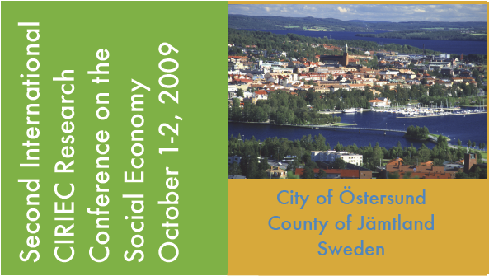

The Social Economy
in a world facing a global crisis

Information and
Call for Papers

www.socek.se/ciriec_research_2009

Introduction
The world is undergoing rapid and extensive changes associated with globalization, conflicting ideas about the roles of the State and the reconfiguration of communities.
The financial crisis that was followed by market decline and the fear of a world wide recession demonstrated the vulnerability and interlinkage of the global market and its national economies. In this context of decreasing markets, the role of Social and Public Economy is more of interest in the public discussion. The Social Economy contribution to local and regional sustainable development, to the welfare system and to entrepreneurship and jobcreation becomes more evident and important. Social Economy in this context is made of co-operatives, mutuals, non-profit organisations like associations and foundations and contains several approaches that can be of use to individuals in local communities, social entrepreneurs, policy makers, community activists and researchers.

The 2nd International CIRIEC Research Conference will focus on the developments within the theme "The Social Economy in a world facing a global crisis".
During the two conference days, researchers and practitioners from different parts of the world will come together and create new knowledge and awareness on different Social Economy models e.g. in Eastern Europe and Russia, in Africa, North and South America, Asia or other world regions, its relation towards social capital, regional development, social innovation, community and social entrepreneurship.

This conference follows the great success of the 1st International CIRIEC Research Conference on Social Economy in Victoria, Canada, 2007. The Mid Sweden University, the City of Östersund, SISE/CIRIEC-Scandinavia and CIRIEC International invite you to participate and present the most recent developments within the international research on Social Economy.

Thematic areas of the conference
The following presentation describes the thematic areas of the 2nd International CIRIEC Research Conference on the Social Economy:

- Social Economy plurality in entrepreneurial forms:
- Community entrepreneurship and social entrepreneurs
- A catalyzer for social cohesion and community development in local areas
- Social economy entrepreneurship vis-a-vis global energy needs and climate change

- The Social Economy and Social capital:
- Regional and local development by entrepreneurship and social capital
- Instruments and research regarding social capital and its social and economic impact on development
- Human resources for strengthening networking and social integration

- The Social Economy - creating employment and environmental, social and economic sustainability
- Combatting unemployment and discrimination
- Environment protection and sustainable development
- Emerging sectors in sustainable production and services

- The Social Economy and governance:
- Social responsibility and quality standards
- Management and participatory governance
- Competition and respect of social economy identity

- The Social Economy facing the world financial crisis
- Ecobanking and microcredit systems for social economy enterprises
- Community banking and new social banking
- The Co-operative banking system - impact of the financial crisis

- The Social Economy and new public policies:
- Interaction and partnerships with public and private actors
- Social innovation and its impact on regions and territories
- New opportunities after the crisis

- Social economy development in different world regions:
- Renaissance of Social Economy in the new EU Member States and Russia
- Social economy in Africa - actors, projects and aid policies
- Social economy in South America, its role for employment and social welfare
- Developments in the Social Economy sector in Asian countrie

- Is there a new Nordic model of Social economy arising?
- contribution of the Nordic (Baltic) model of Social economy to developments in the new European Member States, Eastern Europe and Russia?
- economic development and competitiveness?
- development and impact on the welfare state?

It is important to include the gender perspective in all the different themes.
The scientific committee will take that into consideration in the evaluation of abstracts.

Objectives of the 2nd International CIRIEC Research Conference 2009
The conference objectives are:
- Increase internationally the scientific knowledge and recognition of the Social Economy
- Strengthen and encourage participatory research between researchers and practitioners in the Social Economy
- Provide researchers, practitioners and governments the opportunity to exchange knowledge and viewpoints on the Social Economy in different national contexts

Researchers, government representatives, public sector representatives and professionals, working in the Social Economy sector are invited to participate in the conference.

General Structure of the conference

The conference is structured around three axes:

1. Two Plenary sessions
2. Four sessions with 8 parallel workshops each
3. Poster presentations

Dedicated space will be arranged for displaying posters of the conference participants and their organisations.

Important dates
15/02/09 Deadline for submission of abstracts
15/04/09 Notification of acceptance of abstracts
01/06/09 Deadline for discounted registration
01/09/09 Deadline for submission of papers for publication
01/10/09 First day of the conference

Conference Web page and news update
The conference website is: (www.socek.se/ciriec_research_2009).
Ciriec International (www.ciriec.ulg.ac.be), will as well publish updates regarding the conference.
For continuous updates on the conference webpage, you may syndicate with a newsfeed reader. (URL: http://socek.se/node/feed)

Conference organisers
CIRIEC-International (International Centre of Research and Information on the Public, Social and Cooperative Economy) is a non-governmental international scientific organisation. (www.ulg.ac.be/ciriec)

Its objectives are to undertake and promote the collection of information, scientific research, the dissemination and publication of works on the sectors and activities, where the main aim is to serve the general and collective interest and the organisation of events (congresses, seminars, conferences,...).

Ciriec-International celebrated its 60th anniversary as an organisation in 2007.
Its headquarters are in Belgium and it has sections in 13 countries in Europe, South and North America and Japan. CIRIEC publishes the Annals of Public and Cooperative Economics, a scientific journal that is available from Wiley-Blackwell Publishing: (www.blackwellpublishing.com/apce). It also publishes books and reports.
SISE/CIRIEC-Scandinavia - The Scandinavian Institute of Social and Public Economy (www.socek.se) is one of the national sections of CIRIEC International.
It is organised as a network of various partners and organisations that work with research, information, publication and development of the social and public economy in Sweden and in Scandinavia. The association has its registered office in Östersund.
The Swedish Organisation for Local Enterprises (KFS) is a member of SISE/CIRIEC-Scandinavia. KFS is an employers organisation for companies in the municipal and county council sector. The municipality of Östersund, together with KFS are the founding members of SISE/CIRIEC-Scandinavia.

As from 1st of January 2005, Mid Sweden University became the youngest University in Sweden. A young University has freedom to change and see new openings and possibilities without being tied by tradition. It can contribute to the renewal of the academic activities.
Mid Sweden University (www.miun.se) is located in the middle of Sweden, in three Swedish cities: Östersund, Sundsvall and Härnösand. It is the leading educational institution in the field of flexible learning. Approximately 30 percent of the students at
Mid Sweden University study by flexible learning courses or programmes.
Mid Sweden University is a co-operation partner of SISE/CIRIEC- Scandinavia.

Scientific Committee of the conference
President of the Scientific Committee:
Professor Marie-Louise von Bergmann-Winberg, Midsweden University, Sweden

Members of the Scientific Committee:
Reidar Almås, Senter för landsbygdsutvickling, Trondheim, Norway - to be confirmed
Marie Bouchard, CIRIEC-Canada, University of Québec at Montreal, Canada
Joanna Brzozowska, NAUWC, Krakow, Poland
Rafael Chaves, CIRIEC International, CIRIEC-Spain, University of Valencia, Spain
Danièle Demoustier, CIRIEC-France, University of Grenoble, France
Peter Eichhorn, University of Mannheim, Germany - to be confirmed
Bernard Enjolras , Institute for Social Research, Oslo, Norway - to be confirmed
Stefano Facciolini, LEGACOOP, Italy
Lisa Fröbel, SISE/CIRIEC-Scandinavia, Sweden
Hajime Imamura, CIRIEC-Japan, Toyo University, Japan
Gurli Jakobsen, Copenhagen Business School, Denmark
Bengt Johannisson, Växsjö University, Sweden
Tapani Köppä, University of Helsinki, Ruralia Institute Mikkeli, Finland - to be confirmed
Victor Pestoff, Ersta Sköndal University College, Sweden
Pekka Pättiniemi, Coop Finland, Finland - to be confirmed
Roger Spear, Open University, United Kingdom
Abdou Salam-Fall, University Cheikh Anta Diop of Dakar, Senegal - to be confirmed
Ann-Marie Sätre-Åhlander, Uppsala University, Sweden
Mirta Vuotto, University of Buenos Aires, Argentina - to be confirmed
Stig Westerdahl, Kristianstad University College, Sweden

Honorary Scientific Committee members

Benoît Lévesque, President of CIRIEC International Scientific Council, CIRIEC-Canada, University of Québec at Montreal, Canada
José Luis Monzón Campos, CIRIEC-Spain, University of Valencia, Spain
Ian MacPherson, CIRIEC-Canada, University of Victoria, BC, Canada
Joseph Stiglitz - to be confirmed
Bernard Thiry, CIRIEC International, University of Liege, Belgium

The Scientific Committee of the conference will benefit of the help of the
CIRIEC International Scientific Commission "Social and Cooperative Economy"
presided by Prof. Rafael Chaves.

Submission of proposals for presentations to the Conference
The organisers invite researchers from universities, specialist research centres and practitioners from the Social Economy to take part in the conference and submit abstract proposals relevant to the thematic streams of the event.

Abstracts
The abstracts should be between 250 and 500 words long and include a bibliography. Abstracts shall be submitted preferably in English in order to simplify the work and selection procedure for the Scientific Committee. However optionally we will accept them as well in French, Spanish or German. The abstract shall be submitted by uploading (copy and paste) on the following webpage: www.socek.se/abstract2009.

Accepted papers
The list of accepted abstract papers will be published on the Conference website by
15 April 2009: http://www.socek.se/ciriec_research_2009. Additionally it will be distributed on CD to the conference participants.

Sending full texts
The deadline for sending the full text of the paper for publication is 1st September 2009. Publication of papers received after this date cannot be guaranteed.
Poster presentations will not be accepted unless the researchers have completed the registration process.

Registration
All Conference participants must register. The conference registration fee is 300 Euro.
Early bird registration will allow for participation at 250 Euro.
Registration shall be made through the conference website or by contacting the
Östersund Turism and Conferences Office (www.kongress.ostersund.se) directly.

Grants
University and specialised research centre researchers whose presentation has been accepted and who wish to apply for a grant for the Conference in addition to the discounted registration rate should apply to seconf2009@socek.se. The organising committee will decide on discounts that can be granted under certain conditions.

Official language of the conference
The official language of the conference is English. The plenary sessions of the conference will provide for simultaneous interpretation in French, Spanish and possibly German.
In each of the 4 workshop sessions, there will be only one workshop providing the possibility of simultaneous interpretation from either French, Spanish or German into English (active language).

Conference location
The conference will be held at the Midsweden University in Östersund.
The conference venue is at the campus of Midsweden University.

More information about the conference, its location, about Östersund and its sights can be found on the conference website and respective links.

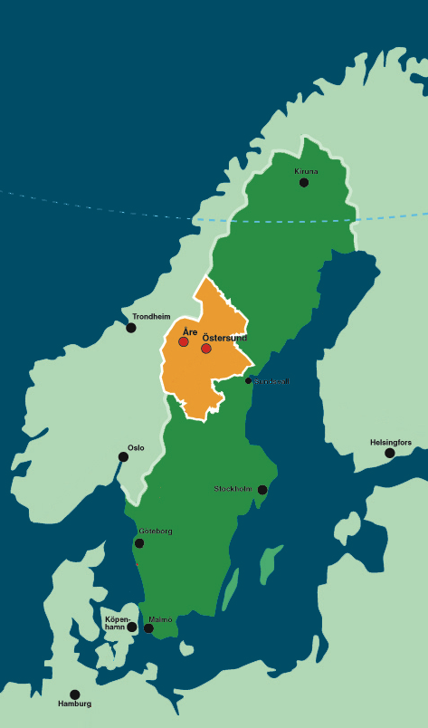
Travel information
International flights will arrive at Stockholm Arlanda airport. From there you will need to take a domestic flight or train connection to Östersund. Flights from Stockholm Arlanda to Östersund are managed by SAS (www.sas.se). Train tickets (from Arlanda C) can be booked at SJ (www.sj.se).
Another option is to arrive in Norway at Oslo airport and take a national flight to Trondheim (Vaernes/Vännäs airport). There is a train connection (Mittnabo-train) between Vaernes/Vännäs airport and Östersund. (www. nsb.no and www.bokatag.se/en/)
Additional travel information will be provided on the conference homepage. Please contact the Östersund Tourism and Conferences Office for any further information. (see addresses and links below)

Further information
For further information on registration, travel, social events, etc. please contact:
Östersund Turism and Conferences Office
Rådhusgatan 44
SE-83182 Östersund, Sweden
Tel. +46 63 144010 Fax: +46 63 127055
e-mail: kongress@ostersund.se

For further information on the conference please contact the conference organisers at:

Conference administration
SISE/CIRIEC-Scandinavia
Kunskapens väg 1, hus P
SE-83133 Östersund
Tel. +46 (0)8 - 51970840
seconf2009@socek.se
www.socek.se/ciriec_research_2009

